Chapter 11, Problem 11.

For the network in Fig. 11.43, assume that the port impedance is

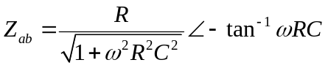

Find the average power consumed by the network when R = 10 kΩ,
C = 200 nF, and i = 33sin (377t + 22°) mA.

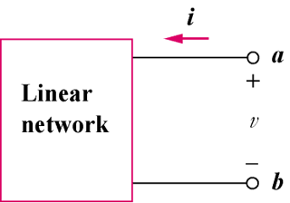

Figure 11.43
For Prob. 11.11.

